Tetsworth Village Fete
Fun Family Dog Show
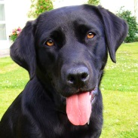
Saturday 30th June 2018 at 1.30pm
Enter your lovely Pooch!
Entries on the day from 1.00pm
Entries £1 per dog per class

Owner’s Name ………………………………………….……
Dog’s Name (s) ………………………………………………
Class(es) entered …………………………………………….
Classes
- The handsomest dog
- Loveliest Lass
- The dog with the best handshake
- Best young handler under 13 years
- The dog with the waggiest tail
- The dog the judge would most like to take home
Entries can be emailed beforehand to: sarah@tetsworthvillagefete.com
Remember to include your name, your dog’s name and the classes you want to enter in your email
The steward will collect your entry fees on the day

With grateful thanks to our sponsors Pet Care of Thame

